**TASK 1**

function isSumN(x,N)

{

let sum=0;

while(x>=1)

{

sum = sum + (x%10)

x = x/10;

x = parseInt(x);

}

if(sum == N)

return true;

else

return false;

}

//first introduce a natural number N

//we set N = 5

var N = 5;

let i = 100

//run a while loop from 100 to 1000

while(i<1000)

{

if(isSumN(i,N)) //calling function isSumN to check if sum == N or not

console.log(i)

i++;

}

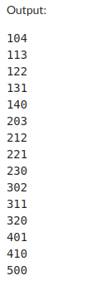

//**TASK 2**

const sides = [3, 2, 2];

function checkValidity(sides)

{

const [a, b, c] = sides;

// check condition

if (a + b <= c || a + c <= b || b + c <= a)

return false;

else

return true;

}

const areaOfTriangle = sides => {

const [a, b, c] = sides;

const sp = (a + b + c) / 2;

const aD = sp - a;

const bD = sp - b;

const cD = sp - c;

const area = Math.sqrt(sp * aD * bD * cD);

return area;

};

if(checkValidity(sides))

console.log(areaOfTriangle(sides))

else

console.log("Sides of the triangles are not valid")

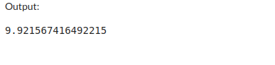

//**TASK 3**

function atIndex(x,arr)

{

let i =0;

while(i<20)

{

if(arr[i] == x)

{break;}

i++;

}

return i+1

}

let arr = []

let x = 0

while(x<20)

{

arr.push(Math.floor(Math.random() * 1000));

x++;

}

//printing 1st line

console.log(arr)

let i =0

//sorting the random integers now

let temp = []

while(i<20){

temp.push(arr[i])

i++

}

temp.sort()

let locationArr = []

let y;

i=0

while(i<20)

{

y = atIndex(temp[i],arr)

locationArr.push(y)

i++;

}

console.log(temp)

console.log(locationArr)

